Use of S’ Indices to Evaluate Synthetic Lethality as a Systems Phenomenon: From Gene Pairs to Network Fragility

Abstract
Classical synthetic lethality (SL) defines vulnerability as a pairwise gene interaction where losing both genes disrupts a vital function. This approach assumes fixed pathways and that drugs largely mimic gene knockouts.
In cancer, mutations in oncogenes and tumor suppressor genes fundamentally reshape cellular signaling, metabolism, replication stress response, and feedback mechanisms. This reorganization gives rise to drug-targetable vulnerabilities that result from the overall system state of the cell, rather than being exclusively linked to individual gene pairs.
To identify these emergent and systemic vulnerabilities, we employ the S′ and ΔS′ metrics as analytical tools for examining SL-like drug responses. S′ serves as an operational potency–efficacy index for ranking perturbations, and in the context of synthetic lethality, S′ and ΔS′ quantify drug responses as genotype‑dependent shifts in the cellular operational state. This systemic SL framework can reveal multi-axis fragilities—such as receptor tyrosine kinase (RTK) dependency, g-protein coupled receptor (GPCR)-homeostasis instability, metabolic brittleness, and mitotic hypersensitivity—that area under the curve (AUC) and EC₅₀ systematically miss and aligns more closely with the complex dependencies of lung cancer genotypes. S’ indices were used to analyze the synthetic-lethal (SL) vulnerabilities in lung cancer cells with mutations in five tumor suppressor genes: PTEN, CDKN2A, RB1, and TP53. Each mutation creates a distinct multi-axis SL landscape reflecting specific cellular fragilities and dependencies, While the SL screens reveal rich, genotype-specific vulnerability landscapes, the distribution of S′ and ΔS′ values suggests that only a focused subset of compounds produce the deep, high-confidence synthetic-lethal effects that are most likely to translate into robust therapeutic opportunities.

Introduction
Classical synthetic lethality (SL) is defined as a pairwise genetic interaction in which the loss of either gene alone is tolerated, but the simultaneous loss of both genes results in cell death because a single essential function is disrupted [1,2]. This framework assumes that two discrete gene losses converge on a single essential function, that the interaction is stable across contexts, and that a drug can reliably phenocopy the second knockout. However, large-scale perturbation datasets consistently show that oncogenic states reshape signaling, metabolism, replication stress, and feedback architecture in ways that cannot be reduced to a single partner gene [2-4]. The same pathway can produce opposite phenotypes in different genotypes, drugs nominally targeting the same node can diverge sharply in effect, and vulnerabilities often arise not from the loss of a specific gene pair but from the cumulative strain placed on a stressed, compensating network [5].
An approach to synthetic lethality that reframes vulnerability as a systemic, state-dependent failure mode [6] is therefore required, because the cell itself—not the gene pair—is the true unit of failure. In such a systemic synthetic-lethality (systemic SL) framework, a genotype creates a characteristic pattern of metabolic, mitotic, signaling, or homeostatic fragilities, and diverse perturbations that overload those weak points become selectively lethal. This systems-level view captures the multi-axis, context-dependent, and emergent nature of real drug responses and provides a mechanistic foundation that classical SL cannot accommodate, enabling a more reliable and therapeutically relevant map of genotype-specific vulnerabilities.
In a previous paper (in preparation) we introduced the S′ and ΔS′ indices for analyzing high-throughput viability screening data. S′ integrates potency and efficacy into a single, unitless, variance-stabilized index that preserves the direction of the drug’s effect (inhibition vs disinhibition) and normalizes away system-specific scaling. Since S′ maintains directionality and combines potency with efficacy, it is able to detect emergent behaviors—including paradoxical activation, partial disinhibition, or non-monotonic responses—that standard metrics like IC50 and EC50, focused only on potency, often overlook. ΔS′ measures genotype-specific differences in drug-induced cell responses, such as those observed between wild type (WT) and mutant cell populations detecting increased drug sensitivity or -resistance. In this framework, ΔS′ can serve as a quantitative signature of systemic synthetic lethality, capturing synthetic-like phenotypes that arise from distributed network fragility rather than from disruption of a single molecular interaction.
This stands in contrast to AUC and EC₅₀, which quantify isolated curve features—overall area or the concentration at which a response crosses 50%. These metrics implicitly assume that drug response is governed by a single dominant mechanism captures the relevant biology and typically fails to account for complex, multi-modal biological responses [7,8]. In cancer cells with tumor-suppressor backgrounds, however, vulnerabilities arise from multi-axis, state-dependent failures involving signaling, metabolism, replication stress, and feedback rewiring [9-11]. AUC and EC₅₀ cannot detect these emergent phenotypes because they discard the very information that encodes them: directionality, efficacy, and the relative scaling of the response. S′ and ΔS′ therefore detect vulnerabilities that AUC and EC₅₀ systematically miss, including GPCR-homeostasis fragility, pan-RTK dependency, metabolic-stress brittleness, and mitotic-stress hypersensitivity.
Synthetic lethality has been explored in lung cancer [3,12-14], but its clinical success is mostly limited to specific subgroups with clear mechanisms [15,16]. For most lung tumours—especially those with KRAS, TP53, RB1, STK11, or KEAP1 mutations—the classical synthetic lethality framework has not met expectations. This is likely due to extensive system-level rewiring in lung cancers [17-19], which undermines pairwise gene–gene interaction models. Classical approaches have had limited impact, as lung cancer involves complex pathway rerouting, metabolic flexibility, and adaptation, making single compensatory pathways rare [17,20,21]. While some successes exist, such as PARP sensitivity in SCLC subsets or DNA-repair vulnerabilities in BRCA-like NSCLC, most predicted SL pairs fail because lung tumours use redundant networks for essential functions, allowing cells to survive by rerouting when an “SL partner” is targeted.
A systemic synthetic-lethality framework is therefore required. Here, we apply the S′ operational-state metric to DepMap lung-cancer viability datasets, treating vulnerability as a shift in the S′-defined cellular state rather than as the product of a single gene–gene interaction. In this view, replication stress, redox imbalance, RTK dependency, GPCR-homeostasis instability, and mitotic fragility appear as coherent ΔS′ signatures that reflect distributed, state-dependent network weakness. This systems-level perspective aligns with the multi-axis dependencies characteristic of PTEN-, CDKN2A-, RB1-, and TP53-mutant lung cancers and provides a more realistic foundation for identifying actionable vulnerabilities. These considerations motivate the central question of this study: how S′ and ΔS′ can resolve genotype-dependent synthetic-lethal vulnerabilities and isolate the small subset of perturbations that produce true, selective collapse in mutant cells while distinguishing them from genotype-independent cytotoxic responses.

RESULTS

ΔS′ Signatures Define System‑Level Vulnerabilities Across Genotypes
We used ΔS′ to quantify how each tumor‑suppressor genotype alters the global drug‑response landscape. Because ΔS′ measures genotype‑specific shifts in the S′‑defined operational state, it provides a direct readout of system‑level fragilities rather than pairwise gene interactions.
Examining ΔS′ across major signaling, metabolic, and stress‑response pathways revealed distinct vulnerability architectures—multi‑axis stress sensitivity in RB1, metabolic and RTK fragility in PTEN, selective signaling dependencies in CDKN2A, and mitotic‑stress hypersensitivity in TP53. These patterns illustrate the emergence of systemic synthetic lethality and motivate the pathway‑level analyses that follow.
Across the five tumor-suppressor genotypes, ΔS′ signatures revealed coherent, pathway-level patterns of vulnerability that are not apparent from classical curve-reduction metrics. RB1-mutant cells exhibited broad, multi-axis fragility, with strongly negative ΔS′ values across RTK inhibitors, GPCR agonists and antagonists, carbonic-anhydrase inhibitors, JAK/ROCK inhibitors, and mitotic-spindle poisons, consistent with a globally stressed state characterized by replication-stress amplification and signaling-homeostasis instability.

Synthetic-lethal profiles across PTEN, TP53, CDKN2A, and RB1 mutations in lung cancer cells
Across the three A–D panel sets (Figures X, Y, Z) the data reveal three mechanistically distinct classes of responses, each with different implications for downstream hit development and therapeutic translation. The most therapeutically relevant signals arise from compounds that inhibit growth in both WT and mutant cells (S′ > 0) while producing mutant-selective inhibition (ΔS′ < –2). These represent the clearest synthetic-lethal interactions, with PTEN- and CDKN2A-mutant cells showing broad vulnerability across RTK/PI3K/mTOR, proteostasis, and replication-stress pathways, while TP53- and RB1-mutant cells show a narrower but deeper dependence on mitotic-checkpoint integrity, particularly KIF11/Eg5 and Aurora-axis inhibitors. These S′-positive, ΔS′-negative compounds form the primary pool of actionable hits, offering a rational basis for genotype-stratified therapeutic strategies.
A second class of compounds—those with negative S′ values in both WT and mutant cells—reflects disinhibition, meaning enhanced growth rather than suppression. Even when ΔS′ < –2 indicates greater disinhibition in WT than mutant cells, the biology is therapeutically unfavorable: any compound that promotes growth in the mutant background is inherently contraindicated. Moreover, more negative S′ values in WT cells imply preferential WT survival, which could undermine therapeutic selectivity and enrich non-target populations. These compounds are therefore best interpreted as anti-hits—informative for understanding stress-response wiring but unsuitable for therapeutic development or combination strategies.
The third set, characterized by extreme ΔS′ values, contains a mixture of S′ geometries. Only compounds with mutant S′ ≥ 0 and substantially more inhibition in the mutant than WT represent meaningful opportunities. These cases may reveal Achilles-heel vulnerabilities—for example, profound dependence on AKT-survival signaling in RB1-mutant cells or metabolic buffering in PTEN-mutant cells—but require careful filtering to exclude any compound that increases mutant growth. When this filter is applied, the remaining extreme-ΔS′ compounds can guide mechanistic prioritization, analog development, and rational combination design.
Taken together, these three panel sets define a coherent therapeutic roadmap: prioritize S′-positive, ΔS′-negative compounds as true synthetic-lethal hits; treat negative-S′ compounds as liabilities that should be excluded from development; and mine extreme-ΔS′ interactions only when the mutant background remains inhibited. This framework ensures that downstream hit selection focuses on compounds that genuinely suppress mutant cell growth while avoiding agents that risk disinhibition or preferential WT survival.

Figure X. Compounds displaying synthetic lethal signatures in lung cancer cells under the influence of tumor suppressor gene mutation: (A) PTEN, (B) TP53, (C) CDKN2A, or (D) RB1. A SL signature was defined by positive S′ values in both WT and mutant cells and ΔS′ < –2—indicating at least moderate mutant-selective inhibition. ΔS′ < –4 indicated strong mutant-selective inhibition. Data bars (blue), juxtaposed with numerical values, illustrate the relative magnitude of S’ values, with longer bars representing higher values (more inhibition) and shorter bars representing lower values. ΔS’ values are color coded with higher intensity green representing lower values (more selectivity). "C:\Users\godet\OneDrive\Desktop\lung MS\lung SSL summary.xlsx"

PTEN-mutant lung cancer cells exhibit a deep, multi-axis synthetic-lethal phenotype
PTEN-mutant lung cancer cells displayed deep, synthetic-lethal responses with ΔS′ values ranging from –5.6 to –4.2 in the top ranked compounds. These magnitudes fall well beyond the moderate SL band (–2 to –4) that dominated most genotypes and instead reflect catastrophic mutant-selective collapse.

A focused analysis of the deepest synthetic‑lethal responses revealed a small subset of compounds that produced exceptionally strong mutant‑selective inhibition, with ΔS′ values ranging from –5.6 to –4.2. These agents consistently generated modest WT S′ values (typically 0–3) alongside markedly elevated mutant S′ values (4–11), yielding large negative ΔS′ shifts well outside the moderate SL band. Mechanistically, these high‑magnitude interactions clustered into several coherent classes. Mitotic and spindle‑assembly disruptors such as litronesib produced some of the strongest effects, consistent with collapse of mitotic checkpoint compensation in the mutant background. A second group of deep‑SL compounds targeted RTK‑proximal signaling, including axitinib, tyrphostin‑AG‑1296, and selumetinib, reflecting a heightened reliance on growth‑factor signaling for survival. Additional strong responses were observed with pevonedistat, indicating vulnerability to NEDD8‑dependent proteostasis, and with mechlorethamine and hydroxyurea, which amplify replication stress. Several micro-environmental and GPCR‑linked agents, including sertindole, darifenacin, and saxagliptin, also produced ΔS′ values in the deep‑SL range, suggesting that perturbations in extracellular signaling tone disproportionately destabilize the mutant state. Together, these compounds represent the top tier of synthetic‑lethal potency, marking pathways where the mutant genotype is likely unable to compensate once perturbed.

RB1-mutant lung cancer cells display a deep, multi-modal synthetic-lethal phenotype dominated by mitotic, checkpoint, PI3K/AKT, and transcriptional stress
RB1-mutant lung cancer cells exhibited one of the strongest and most coherent synthetic-lethal signatures across all tumor suppressor backgrounds analyzed. The upper tier of ΔS′ values (–6.5 to –4.0) representing mutant-selective collapse.
A dominant vulnerability emerged in mitotic and G2/M checkpoint control, with strong SL responses to Aurora kinase inhibitors (barasertib, barasertib-HQPA, SNS-314, ZM-447439), PLK inhibitors, and spindle poisons (litronesib, maytansinol-isobutyrate). RB1 loss disrupts E2F regulation and accelerates S-phase entry, forcing cells to rely heavily on mitotic checkpoint integrity. The data show that once this compensatory checkpoint is perturbed, RB1-mutant cells undergo selective mitotic catastrophe.
A second major axis involved PI3K/AKT pathway dependency, highlighted by MK-2206 (ΔS′ = –6.5, the strongest hit), NVP-BEZ235, taselisib, GDC-0941, uprosertib, and GSK2110183. RB1 loss is known to increase reliance on AKT-mediated survival signaling; your data reveal that AKT inhibition is profoundly synthetic-lethal in this background.
RB1-mutant cells also showed strong SL responses to DNA replication and repair stress, including olaparib, talazoparib, niraparib, hydroxyurea, melphalan, busulfan, and fludarabine. This is consistent with RB1’s role in regulating replication origin licensing and maintaining replication fidelity. Without RB1, cells become hypersensitive to replication stress and DNA damage, producing selective collapse when challenged.
A substantial cluster of hits involved transcriptional and epigenetic regulators, including OTX015 (BET inhibitor), belinostat (HDAC), ACY-1215, PTC-209, and ICG-001. RB1 interacts with chromatin remodelers and transcriptional repressors; its loss destabilizes transcriptional homeostasis, making the mutant background more vulnerable to chromatin and transcriptional perturbation.
Another recurring axis involved RTK/ERBB and growth-factor signaling, with selective responses to tivozanib, NVP-AEW541, rociletinib, sunitinib, tyrphostin AG-1296, and NVP-BHG712. These compounds suggest that RB1-mutant cells compensate for deregulated cell-cycle progression by increasing reliance on extracellular mitogenic signaling, creating a synthetic-lethal dependency on RTK pathways.
Finally, a broad set of microenvironmental, GPCR, and ion-channel modulators (aspirin, phenylbutazone, atipamezole, pheniramine, ebastine, SB-366791, oxazepam) also produced selective inhibition. These hits indicate that RB1-mutant cells are unusually sensitive to perturbations in extracellular signaling tone, likely due to altered E2F-driven transcriptional feedback loops.
Together, these results reveal that RB1 loss generates a deep, multi-axis synthetic-lethal landscape, with dominant vulnerabilities in mitotic checkpoint control, PI3K/AKT survival signaling, replication stress response, transcriptional regulation, and RTK-driven growth signaling. Rather than a single pathway dependency, RB1-mutant lung cancer cells exhibit system-level fragility, consistent with the central role of RB1 in coordinating cell-cycle progression, replication fidelity, and transcriptional control.

TP53-mutant lung cancer cells exhibit a spindle-checkpoint–dominated synthetic-lethal phenotype with secondary vulnerabilities in apoptosis, replication stress, and cytoskeletal integrity
TP53-mutant lung cancer cells displayed a high-intensity synthetic-lethal signature. There was a dominant SL axis represented by mitotic spindle KIF11/Eg5 inhibitors with the strongest SL responses (ΔS′ from –6.2 to -4.7) produced by litronesib, SB-743921, filanesib, and ispinesib (Figure X.). Cells with a TP53 the mutant background consistently experienced substantially greater inhibition than TP53-wild-type cells.

Figure X. Differential S′ responses to kinesin‑5 (KIF11) inhibitors in TP53‑wild‑type and TP53‑mutant lung‑cancer cell lines. Horizontal bars show the operational‑state displacement (S′) induced by five KIF11 inhibitors—K‑858, ispinesib, litronesib, filanesib, and SB‑743921—in TP53‑wild‑type (blue) and TP53‑mutant (orange) lung‑cancer cell lines. Red labels indicate the corresponding ΔS′ values (S′ – S′), quantifying genotype‑specific sensitivity. Four inhibitors—ispinesib, litronesib, filanesib, and SB‑743921—produce large negative ΔS′ values (–4.7 to –6.2), indicating strong TP53‑selective inhibition. These deep mutant‑selective responses reflect the inability of TP53‑mutant cells to activate the p53‑dependent post‑mitotic G1 tetraploidy checkpoint following spindle disruption, leading to uncontrolled 4N→8N cycling, replication stress, and mitotic catastrophe. K‑858 shows a smaller but still negative ΔS′ (–1.9), consistent with a weaker but directionally similar vulnerability. "C:\DESKTOP-EE703MN_D\mocomakers 2024\depmap portal\multiple tumor suppressors\median\lung_TP53_ median+delta_s_prime.xlsx"

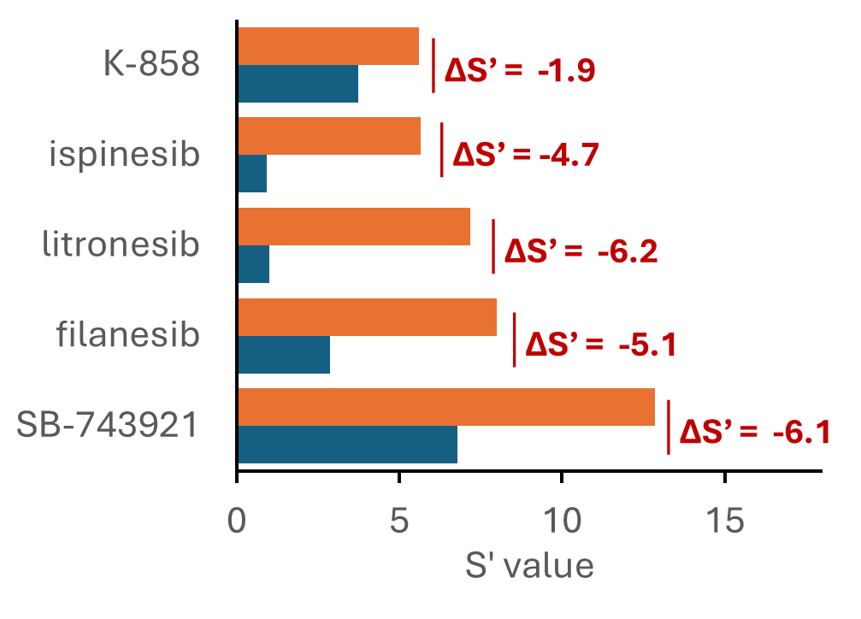
Under normal conditions, p53 arrests cells that exit mitosis aberrantly—such as after spindle failure or cytokinesis defects—preventing 4N cells from re‑entering S phase. In TP53‑mutant cells, loss of p53 disables the post‑mitotic G1 tetraploidy checkpoint [22,23]. KIF11 inhibitors disrupt bipolar spindle formation and drive cells into mitotic slippage, generating exactly this 4N state. TP53‑wild‑type cells halt here, but TP53‑mutant cells proceed into another round of DNA replication, accumulating severe replication stress, chromosome mis‑segregation, and ultimately mitotic catastrophe. This unchecked 4N→8N cycling explains why in TP53‑mutant lung cancer cells KIF11 inhibitors produce deep ΔS′ values and why KIF11 inhibition form a particularly strong synthetic‑lethal response node.
Several compounds formed secondary SL nodes, and those nodes included 1) replication stress or DNA damage (rigosertib, docetaxel, paclitaxel, and albendazole) with ΔS′ ranging from –3.3 to -2.0) apoptotic priming and survival-signaling vulnerabilities (navitoclax (ΔS′ = –3.2), 2-methoxyestradiol (ΔS′ = –2.0)).

CDKN2A-mutant lung cancer cells exhibit coordinated synthetic-lethal vulnerabilities across mitotic, growth-signaling, metabolic, and microenvironmental axes
Across the CDKN2A-mutant lung cancer panel, the compounds ranitidine, filanesib, everolimus, and levonorgestrel produced the highest selective loss of viability in the mutant background (ΔS′ between –4.8 and –4.0. Inclusive of all top scoring compounds, the strongest mechanistic dependencies converged on mitotic and cell-cycle stress pathways, including KIF11/Eg5 inhibitors (filanesib, ispinesib), Aurora/PLK pathway inhibitors (barasertib-HQPA, ENMD-2076, rigosertib), and agents that disrupt spindle integrity. These findings align with the known role of CDKN2A in enforcing the G1/S checkpoint.
A second major axis involved growth-factor and survival signaling, with selective sensitivity to mTOR/AKT inhibitors (everolimus, MLN0128, GSK2110183) and multi-target RTK/ERBB inhibitors (lucitanib, pazopanib, neratinib, dovitinib). Additional SL-like responses emerged in epigenetic and transcriptional regulation (azacitidine, ACY-1215, indisulam), metabolic rigidity (dichloroacetate, PFK-015), and apoptotic priming (navitoclax, betulinic acid). Finally, a surprisingly coherent set of hits involved microenvironmental and GPCR/ion-channel modulators (ranitidine, levocetirizine, AM-251, clomifene, mozavaptan, ibutilide), indicating that CDKN2A-mutant cells are more sensitive to perturbations in extracellular signaling tone.

Genotype‑independent high‑S′ responses
The compounds in panels A–D represent the opposite end of the response spectrum from synthetic‑lethal (SL) hits. Instead of showing mutant‑selective inhibition (ΔS′ < –2), these compounds show very strong inhibition in both WT and mutant cells (S′ > 4) and ΔS′ values tightly clustered between –0.5 and +0.5, indicating that the two genotypes respond almost identically. This pattern defines a genotype‑independent cytotoxic response.

Figure X. Genotype-independent high-magnitude responses in lung cancer cells.
The tables list compounds that produced uniformly strong growth inhibition (S′ > 4) in both wild-type and mutant lung cancer cells while maintaining ΔS′ values between –0.5 and +0.5, indicating no meaningful differential response across tumor-suppressor genotypes. Panels A–D correspond to cells harboring mutations in PTEN, TP53, CDKN2A, or RB1, respectively. Compounds in this group include taxanes, epothilones, camptothecins, proteasome inhibitors, HSP90 inhibitors, and other broadly cytotoxic agents. Their tightly clustered ΔS′ values demonstrate genotype-independent activity, reflecting inhibition of core cellular machinery rather than exploitation of mutation-specific vulnerabilities. These compounds therefore serve as non-selective cytotoxic controls, contrasting with synthetic-lethal hits by showing equivalent potency in both WT and mutant backgrounds and offering no genotype-specific therapeutic window.

These compounds fall into a small number of mechanistic classes—taxanes, epothilones, camptothecins, proteasome inhibitors, HSP90 inhibitors, and DNA‑damaging agents. All of these are broad‑acting cytotoxic or cytostatic agents that: a) target core cellular machinery (microtubules, topoisomerases, proteasomes, transcriptional regulators), b) produce high‑magnitude inhibition regardless of tumor‑suppressor genotype, and c) do not rely on a specific genetic vulnerability to exert their effect. In other words, these compounds kill cells because they are potent and efficacious, not because they exploit a mutation‑specific weakness.
Precision-oncology S′ windows for WT and mutant cells
One of the potential advantages of the S’ indices is that they have the potential to act as a precision oncology framework for hit triage, biomarker selection, and therapeutic decision-making. A precision-oncology framework built on S′ windows for WT and mutant cells needs to do three things simultaneously: define when a compound is therapeutically useful, define when it is unsafe or counter-therapeutic, and define when it is simply genotype-independent background cytotoxicity. The S′/ΔS′ system appears to contain all those elements as exemplified in the Table.

Integrated classification
Category | WT S′ window | Mutant S′ window | ΔS′ window | Therapeutic implication
Actionable SL hit | 0–4 | ≥4 | ≤ –2 | Best candidates for targeted therapy
High-confidence SL | 0–4 | ≥4 | ≤ –4 | Deep, mutation-specific collapse
Genotype-independent cytotoxic | >4 | >4 | –0.5 to +0.5 | Potent but non-selective; not precision oncology
Disinhibition (exclude) | Any | <0 | Any | Promotes mutant growth; unsafe
Extreme selectivity | ≤0 | ≥4 | ≤ –4 | Promotes WT growth; mostly unsafe

This matters as separates true SL hits from broad cytotoxics and dangerous disinhibitors; it provides a numerical framework for hit triage, medicinal chemistry, and biomarker selection; it enables genotype-stratified clinical hypotheses (e.g. TP53/RB1 → spindle-checkpoint inhibitors, PTEN/CDKN2A → PI3K/RTK/proteostasis); and helps ensures that only compounds that inhibit the mutant and spare WT.

Genotype-specificity of test compound sensitivities
Venn diagrams (Figure X A and B) were used to visualize how compounds with either a synthetic-lethal (SL) signature or a cytotoxic signature distribute across PTEN-, CDKN2A-, RB1-, and TP53-mutant lung-cancer cell lines. Each circle represents the set of compounds meeting the predefined S′/ΔS′ criteria for a given genotype, and overlapping regions indicate compounds producing similar responses across genotypes.

Figure X. Venn diagrams illustrating compounds with (A) a synthetic-lethal signature (S′ > 0 and ΔS′ < –2) and (B) a cytotoxic signature (S′ > 4 and ΔS′ between –0.5 and +0.5) across TP53-, RB1-, PTEN-, and CDKN2A-mutant lung-cancer cell lines. ΔS′ values were computed for matched mutant/wild-type pairs. Diagrams were generated using Venny (Oliveros, J.C. 2007–2015; https://bioinfogp.cnb.csic.es/tools/venny/
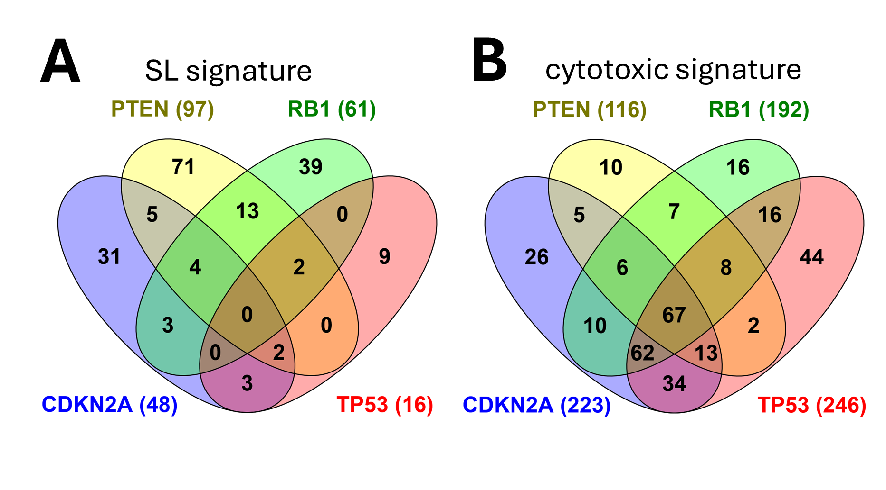
Synthetic-lethal responses were largely genotype-specific
The SL Venn diagram (Figure A) shows that compounds with an SL signature (S′ > 0 and ΔS′ < –2) form distinct, genotype-specific vulnerability spaces rather than a shared synthetic-lethal core. Each tumor-suppressor genotype retains a substantial set of uniquely selective compounds, with PTEN and RB1 exhibiting the largest private repertoires. Pairwise overlaps are present but modest—most prominently between PTEN and RB1—while TP53 shares very few SL compounds with any other genotype. Notably, no compound appears in all four genotypes, underscoring that mutant-selective responses arise from non-redundant, mutation-specific operational-state shifts rather than universal vulnerabilities. This pattern reinforces that synthetic lethality in lung cancer is highly stratified, with each tumor-suppressor mutation generating its own selective collapse points and only limited convergence across related genotypes.

Cytotoxic responses formed a broad, genotype-independent core
In contrast, the cytotoxic Venn diagram (Figure B) shows a large shared core of 67 compounds meeting the genotype-independent cytotoxic criteria (S′ > 4 in both WT and mutant cells; ΔS′ between –0.5 and +0.5). The broad, symmetric overlaps and extensive central intersection indicate that these agents inhibit all four genotypes equivalently, reflecting perturbations of fundamental, non-rewired cellular machinery. These compounds do not induce genotype-dependent operational-state transitions and therefore lack selective vulnerability signatures.

Systemic interpretation of the Venn structure
Together, the diagrams illustrate the central principle of the systemic SL framework: compounds cluster not by nominal target or classical mechanism of action, but by the operational-state failures they induce within a rewired network. The cytotoxic diagram reflects a regime in which all genotypes converge on the same inhibited state (high S′, ΔS′ ≈ 0), whereas the SL diagram reveals sparse, genotype-specific overlaps that map directly onto mutation-dependent network fragilities. Vulnerability is therefore a conditional property of the system state, revealed only when perturbations push mutant cells across their unique adaptive limits.

SL Frequencies in RB1-Mutant Lung Cancer Cells
Across the RB1-mutant screen, only a small fraction of compounds produced a meaningful synthetic-lethal response, underscoring the specificity of RB1-linked vulnerabilities. Approximately 5% of compounds (72 of 1401) generated a clear SL signature—defined by positive S′ values in both WT and mutant cells and ΔS′ < –2—indicating moderate mutant-selective inhibition. Within this group, an even smaller subset, 0.43% of compounds (6 of 1401), produced deep SL responses with ΔS′ < –4, representing the most robust and biologically compelling dependencies. These interactions typically corresponded to pathways that directly intersect RB1-driven compensatory mechanisms, such as mitotic checkpoint reliance or PI3K/AKT survival signaling.
In contrast, a much larger fraction of the library—14% of compounds (200 of 1401)—showed genotype-independent responses, characterized by WT and mutant S′ values > 4 and ΔS′ values between –0.5 and +0.5. These compounds are broadly cytotoxic or cytostatic, affecting both genotypes similarly and therefore lacking selective relevance for RB1-mutant contexts.
These types of responses were found for all tumor suppressor genotypes examined. Together, these proportions highlight a key feature of RB1-associated synthetic lethality: true genotype-selective vulnerabilities are uncommon [3,24] if not mechanistically coherent, while the majority of compounds that display inhibition did not exert genotype-selective responses. This distribution reinforces the value of ΔS′-based operational SL metrics for distinguishing mutation-specific dependencies from general cytotoxicity, and it emphasizes that only a small, high-confidence subset of compounds warrants deeper mechanistic or translational follow-up.

RB1-mutant lung-cancer cells exhibit selective vulnerability to mitotic-checkpoint disruption
To determine how RB1 status shapes drug sensitivity, we compared S′ values for PARP, Aurora kinase, PLK, and CDK inhibitors in RB1-wild-type and RB1-mutant lung-cancer cell lines. The resulting radar charts reveal a graded hierarchy of RB1-dependent vulnerabilities that aligns with the systemic synthetic-lethality framework.

Figure X. Radar charts showing S′ values for PARP, Aurora kinase, PLK, and CDK inhibitors in RB1-wild-type (blue) and RB1-mutant (orange) lung-cancer cell lines. Each chart displays the operational-state displacement (S′) induced by individual compounds within a drug class, enabling visualization of genotype-specific sensitivity patterns. PARP inhibitors showed inconsistent separation between WT and RB1-mutant cells, but several agents—olaparib, talazoparib, niraparib, AZD2461, and PJ-34—exhibited ΔS′ < –2, indicating compound-specific RB1-dependent sensitivity. In contrast, Aurora kinase inhibitors produced consistently higher S′ values in RB1-mutant cells across nearly all compounds, with SNS-314, AMG900, barasertib-HQPA, barasertib, and ZM-447439 each reaching ΔS′ < –2, reflecting strong mutant-selective inhibition and collapse of mitotic-checkpoint integrity. PLK inhibitors showed modest but uniform elevation of S′ in RB1-mutant cells, although none reached the ΔS′ < –2 threshold. CDK inhibitors displayed a similar pattern, with only indisulam producing a ΔS′ < –2 response. Together, these profiles demonstrate that RB1 loss confers pronounced vulnerability to perturbations of mitotic control, whereas PARP inhibition produces compound-specific synthetic-lethal effects.

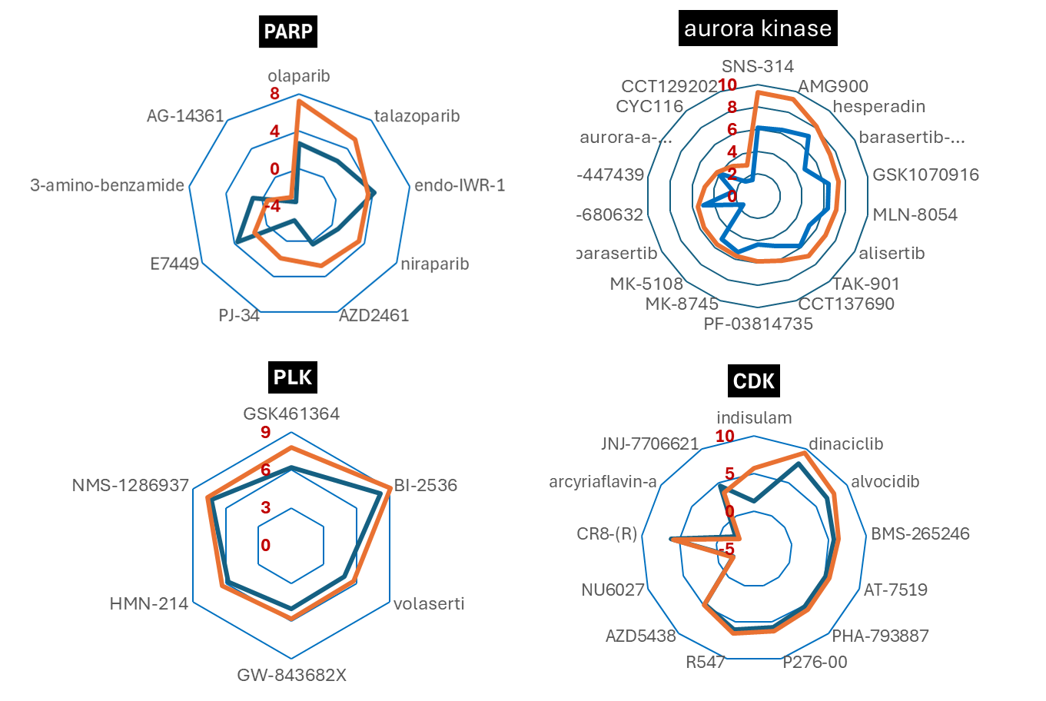

PARP inhibitors showed minimal and inconsistent separation between WT and RB1-mutant cells, indicating that RB1 loss does not broadly sensitize cells to PARP-mediated DNA-repair inhibition. However, several compounds—olaparib, talazoparib, niraparib, AZD2461, and PJ-34—did reach ΔS′ < –2, demonstrating that a subset of PARP inhibitors can induce a mutant-selective operational-state shift despite the absence of a class-wide effect.
In contrast, Aurora kinase inhibitors produced a strong, coherent RB1-mutant hypersensitivity signature. Nearly all compounds generated higher S′ values in RB1-mutant cells, and several—SNS-314, AMG900, barasertib-HQPA, barasertib, and ZM-447439—exhibited ΔS′ < –2, marking them as high-stringency synthetic-lethal hits. This pattern reflects the collapse of mitotic-checkpoint integrity that characterizes RB1-null cell states.
PLK inhibitors showed a consistent but low-magnitude separation between WT and mutant cells. Although RB1-mutant lines displayed uniformly elevated S′ values, none of the PLK inhibitors reached ΔS′ < –2, suggesting that PLK inhibition perturbs but does not fully destabilize the RB1-mutant mitotic program under these assay conditions. CDK inhibitors displayed a somewhat pattern: RB1-mutant cells showed generally higher S′ values, but only indisulam produced a ΔS′ < –2 response. This selective sensitivity is appears consistent with RB1-mutant dependence on late-cell-cycle CDKs rather than CDK4/6, to which RB1-null cells are intrinsically resistant.
Together, these data show that RB1 loss creates a dominant vulnerability to mitotic-checkpoint disruption, with Aurora kinase inhibitors producing the strongest and most consistent synthetic-lethal responses. PARP inhibition yields only compound-specific effects, while PLK and CDK inhibitors occupy an intermediate space of modest but directionally consistent RB1-dependent sensitivity. This hierarchy appears to reflects the underlying biology of RB1-mutant lung cancer, in which mitotic-checkpoint fragility, rather than DNA-repair deficiency, defines the primary axis of systemic synthetic lethality.

DISCUSSION
This study demonstrates that the S′ and ΔS′ metrics provide a principled framework for identifying systemic, genotype-dependent synthetic-lethal (SL) vulnerabilities in lung cancer. Unlike classical SL, which interprets vulnerability as a fixed pairwise interaction between a mutated gene and a drug target, systemic SL is an emergent property arising from cell system rewiring of pathways leading to network fragility. It is a network failure then, frequently context‑dependent, in which the combined perturbation of two genes, -pathways, or -functional modules exceeds the cell’s adaptive capacity leading to collapse of homeostasis and cell death.
Systemic synthetic lethality emerges from the interplay of many cell signaling interactions including in part: redundancy, buffering, compensatory routes, feedback loops, stress responses, transcriptional rewiring, among others. It is therefore not a fixed property of a gene pair (although gene mutation can play a dominant role) but a conditional property of the cell system-state, reflecting the point at which adaptive mechanisms fail and cell death ensues. Within that context S′ and ΔS′ can be useful quantifying these transitions directly, enabling the detection of emergent SL vulnerabilities that cannot be easily resolved by conventional AUC or EC₅₀.
When applied to tumor suppressor mutant backgrounds in lung cancer cells, this framework yielded characteristic patterns of responses. Across PTEN-, CDKN2A-, RB1-, and TP53-mutant lung cancer cells, the dominant empirical pattern was the emergence of moderate-magnitude SL responses. Most compounds produced mutant-selective inhibition with S′ values in the 2–4 range (corresponding to fold changes of about 3.6 to 27) and ΔS′ values between –2 and –4. These values lie outside the no-effect regime and therefore represent genuine genotype-dependent vulnerabilities, yet they do not reflect catastrophic collapse. Instead, they correspond to partial, stress-inducing perturbations that disproportionately burden the rewired mutant state. This pattern is consistent with the distributed nature of systemic fragility: tumor-suppressor loss destabilizes specific regulatory modules—cell-cycle control, PI3K signaling, mitotic fidelity, or DNA-damage responses—but rarely creates a single dominant point of failure. As a result, most perturbations induce measurable but incomplete displacement of the mutant operational state.
Only a small subset of compounds produced deep, high-confidence SL collapse, defined by mutant S′ > 5 and ΔS′ < –4. These high-magnitude hits clustered into mechanistically coherent classes that intersect directly with the compensatory pathways each genotype relies on for survival. KIF11 and Aurora inhibitors dominated the TP53 and RB1 landscapes, PI3K/AKT inhibitors were selectively potent in PTEN-mutant cells, and mitotic/RTK/mTOR inhibitors emerged in CDKN2A-mutant cells. These compounds represent true systemic SL events: they push mutant cells beyond their adaptive limits, collapsing the distributed network of compensatory modules that maintain viability. Their coherence across genotypes underscores that S′ and ΔS′ do not merely detect potency but resolve the specific operational-state transitions that define actionable synthetic lethality.
The genotype-independent cytotoxic cluster provides a critical contrast that helps to validate this framework. These compounds—taxanes, epothilones, camptothecins, proteasome inhibitors, HSP90 inhibitors, and other broad-acting cytotoxics—produced uniformly high S′ values in both WT and mutant cells, with ΔS′ tightly constrained near zero. Their targets represent essential, non-rewired cellular machinery, and their effects drive all cells into similar inhibited states. Because they do not induce differential operational-state transitions, they lack synthetic-lethal selectivity. This contrast establishes a functional ceiling for non-selective cytotoxicity and sharpens the boundary between broad inhibition and genotype-specific collapse.
Interpreted together, these findings show that S′ and ΔS′ uniquely resolve the architecture of systemic SL. S′ captures the magnitude and direction of operational-state displacement, while ΔS′ quantifies genotype-specific divergence. Moderate-magnitude SL interactions map distributed fragilities, whereas high-magnitude interactions identify the rare perturbations that collapse core compensatory pathways. Genotype-independent cytotoxics, by contrast, reveal no differential state transitions and therefore no actionable vulnerability. This operational-state logic naturally suggests combination strategies: SL-selective backbones (high mutant S′, ΔS′ < –2) can be paired with agents that impose additional stress without erasing the ΔS′ window, deepening collapse along the same fragility axis and which may be explored in future studies.
Together, these results show that S′ and ΔS′ provide a scalable, mechanistically grounded framework for identifying systemic, genotype-dependent synthetic-lethal vulnerabilities and isolating the small subset of perturbations that produce true, high-confidence collapse in PTEN-, CDKN2A-, RB1-, and TP53-mutant lung cancer cells while distinguishing them from genotype-independent cytotoxic responses.

METHODS
Data Sources and Preprocessing
Drug-response and mutation-status data for lung cancer cell lines were obtained from the Cancer Dependency Map (DepMap) portal (https://depmap.org/portal/). The data files were downloaded (secondary-screen-dose-response-curve-parameters.csv (SSDRC); OmicsSomaticMutationsMatrixDamaging.csv (OSMMD)) [25]. The SSDRC is part of the PRISM Repurposing release that contains small molecule viability datasets generated using the Broad Repurposing Library and the PRISM multiplexed cell-line viability assay. The secondary PRISM Repurposing dataset contains the results of pooled-cell line chemical-perturbation viability screens for 1,448 compounds screened against 489 cell lines in an 8-step, 4-fold dilution, starting from 10uM. Both oncology-related and non-oncology related compounds are included in the screens [26]. Only data with the column “passed_str_profiling” marked as “TRUE” were used in the study. For each compound–cell line pair, DepMap provides parameters from a four-parameter logistic (4PL) fit to the viability concentration response curve, including the baseline and final asymptotes, EC₅₀, and Hill slope. Using those parameters, efficacy (Emax) was defined as the difference between the baseline and final asymptotes, and potency was defined by the EC₅₀, the concentration producing 50% of the maximal effect. Tumor-suppressor genotype was assigned by classifying homozygous loss-of-function alterations as mutant and the absence of such alterations as wild-type.
The SSDRC file contained four screens designated HTS002, MTS005, MTS006 and MTS010. From the descriptors used in the mechanism of action (MOA), the compounds included the following: agonists, antagonists, modulators, inhibitors, stimulators, undesignated. IC50 values were available for 52% of compound/cell lines combinations. We used screen “HTS002” as described by Corsello et al. [26] and which was modified by inclusion (replacement or addition) of compounds found in MTS010 which contained the “technical redos” identified by DepMap. It should also be noted that MTS010 was not included in the analysis for Corsello et al. [26] who originally reported the files.
In this study we focused on damaging mutation of tumor suppressor genes [27,28]. Tumor suppressor genes with two (2) mutations have a high frequency of loss of function in their product proteins, and hence these “mutants” where contrasted against the corresponding wild type cells.

Computation of S′: Operational Potency–Efficacy Index
Drug effects were quantified using S′, a variance-stabilized, direction-preserving index that integrates potency and efficacy across the full dose–response range:
$$S^{'}=asinh\left(\frac{E_{\text{max}}}{EC_{50}}\right)$$

The inverse hyperbolic sine transformation (asinh) compresses extreme values while preserving sign, rank ordering, and sensitivity to both inhibitory and disinhibitory responses. High S′ values (potent, efficacious inhibitors) are scaled to prevent dominance in downstream analyses, whereas low and moderate values remain distinguishable. Negative S′ values—arising from disinhibition or paradoxical activation—are retained, enabling detection of non-monotonic or stimulatory behaviors that conventional metrics cannot capture.

Cohort-Level S′
For each compound, the mean$\overline{S^{'}}$ across a defined cohort (e.g., all PTEN-mutant lines) was computed as:
$$\overline{S^{'}}=\frac{1}{n}\sum_{i=1}^{n}{S_{i}^{'}}$$

where $S_{i}^{'}$ is the potency–efficacy index for the $i^{th}$ cell line and (n) is the number of lines in the cohort. This pooled index reduces line-specific noise and captures the shared, genotype-encoded operational response to a perturbation.

Computation of ΔS′: Genotype-Dependent State Shift
Genotype-specific drug effects were quantified using ΔS′, defined as:

$$ΔS^{'}=\overline{S^{'}}wild type-\overline{S^{'}}mutant$$

Negative ΔS′ values indicate greater inhibition in the mutant background, whereas positive values indicate relative buffering or reduced inhibition. Because ΔS′ reflects the difference between two full operational-state indices, it captures genotype-dependent shifts in the entire response landscape, including partial disinhibition, non-monotonicity, and other emergent behaviors that single-feature metrics (AUC, EC₅₀) systematically miss. Within this framework, synthetic-lethal behavior is defined as a sufficiently negative ΔS′, representing a mutation-specific displacement of the cellular operational state.

System-Level Interpretation of S′ and ΔS′
S′ quantifies the net functional consequence of a perturbation on the cellular operational state, independent of the drug’s annotated molecular target. Drugs with unrelated targets can produce similar S′ values if they converge on the same stressed pathway or compensatory bottleneck, while drugs nominally targeting the same node can diverge sharply in S′ if their downstream effects differ across genotypes. Consequently, systemic synthetic lethality cannot be described by classical mechanism-of-action categories; it emerges from state-dependent network fragility, and S′/ΔS′ measure how perturbations displace the system.

Pathway-Level Convergence Derived from S′/ΔS′ Patterns
Because S′ and ΔS′ capture operational effects rather than target identity, compounds were grouped by response convergence rather than classical MOA. Drugs were clustered according to the similarity of their genotype-specific S′ and ΔS′ profiles, forming convergence modules that represent emergent system-level fragility patterns—such as replication-stress, redox-stress, metabolic-stress, survival-signaling, or membrane-stress convergence. These modules were defined directly from the structure of the S′/ΔS′ data, treating pathways as data-driven response signatures rather than predefined mechanistic categories.

Framework for Synthetic-Lethal Classification
The asinh transformation used to compute S′ behaves linearly for small magnitudes (|S′| ≲ 1) and logarithmically for larger values. Thresholds for defining synthetic-lethal behavior were aligned with these mathematical properties:

- S′ > –0.5 to include inhibition biologically indistinguishable from zero
- Mutant S′ ≥ 2 to ensure clear inhibition in the mutant background
- ΔS′ ≤ –2 for moderate-stringency SL
- ΔS′ ≤ –4 for high-stringency effects
Approximate fold-change equivalents at key S′ boundaries follow:

S′ boundary | Fold-change interpretation
4 | ~27× decrease (strong inhibition)
2 | ~3.6× decrease
1 | ~1.18× decrease
0.5 | very small effect
0 | baseline

Interpretation of S′ and ΔS′ Distributions
Histograms of S′ and ΔS′ across all compounds illustrate the full range of operational behaviors.
- S′ > 0 indicates net inhibition, S′ < 0 indicates disinhibition, and values near zero reflect similarity to solvent controls.
- ΔS′ < 0 indicates mutant-selective sensitivity, whereas ΔS′ > 0 indicates relative resistance.
These distributions provide the empirical basis for defining SL thresholds and for distinguishing genotype-independent cytotoxicity (high S′, ΔS′ ≈ 0) from systemic synthetic lethality (negative ΔS′ with preserved WT viability).

Rationale for Using S′ and ΔS′ Instead of AUC or EC₅₀
Classical pharmacologic metrics such as AUC and EC₅₀ summarize isolated curve features and assume a single dominant mechanism of action. These assumptions are incompatible with the multi-axis, context-dependent, and emergent nature of drug responses in oncogenically rewired systems. In contrast, S′ and ΔS′ preserve directionality, efficacy, potency, and curve shape, enabling detection of vulnerabilities arising from distributed network stress—including RTK dependency, GPCR-homeostasis instability, metabolic brittleness, and mitotic-checkpoint fragility. This makes them uniquely suited for mapping systemic synthetic lethality across diverse tumor-suppressor genotypes.

Figure X. Distribution of S′ and ΔS′ values across all compound–cell line responses in lung cancer. (A) S′ histogram showing the full spectrum of operational drug effects. Positive S′ values indicate net inhibition, negative values indicate disinhibition or paradoxical activation, and values near zero correspond to responses indistinguishable from solvent controls. The broad dynamic range reflects the variance-stabilized, direction-preserving nature of the S′ index, which integrates potency and efficacy across the entire dose–response curve.
(B) ΔS′ histogram summarizing genotype-dependent state shifts, computed as the difference between mean wild-type and mutant S′ values for each compound. Negative ΔS′ values denote enhanced inhibition in the mutant background (mutant-selective sensitivity), whereas positive values indicate relative resistance. The distribution illustrates the separation between genotype-independent cytotoxic responses (ΔS′ ≈ 0) and mutation-specific synthetic-lethal shifts (ΔS′ < –2), providing the empirical basis for the tiering thresholds used in this study. Cohns D thresholds.xlsx
HISTOGRAM DS ALL DRUGS.JNB
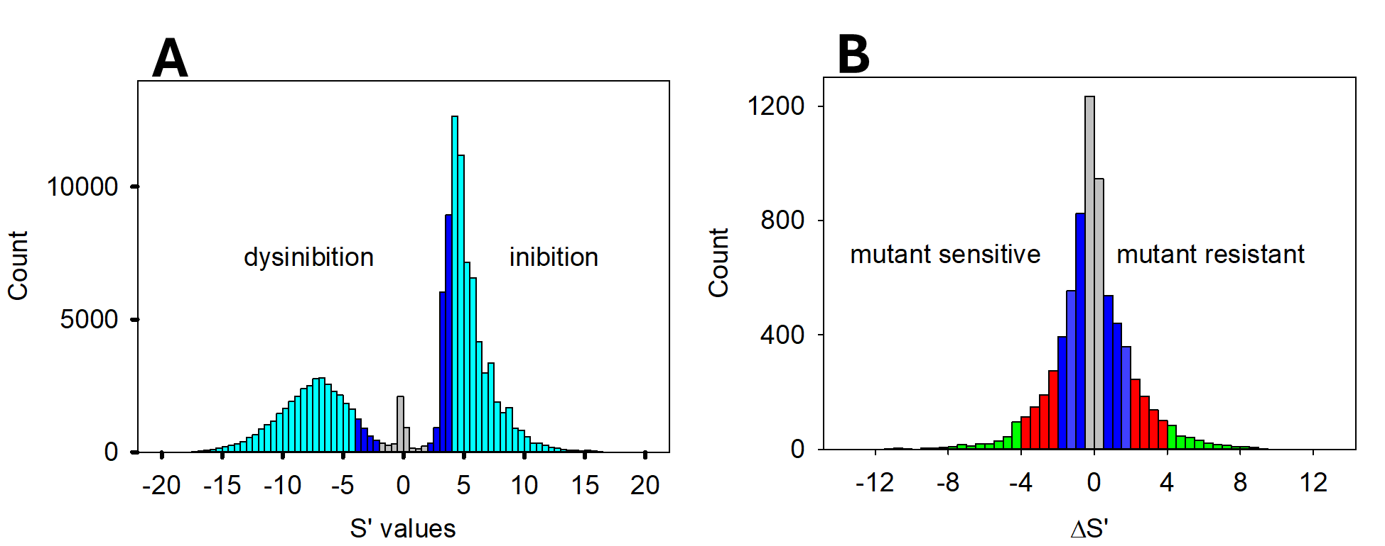

Construction of Synthetic-Lethal and Cytotoxic Venn Diagrams
The Venn diagrams were generated to visualize the overlap of compounds producing genotype-specific synthetic-lethal (SL) responses and those producing genotype-independent cytotoxic responses across lung-cancer cell lines. All classifications were derived directly from the S′ and ΔS′ metrics.
For each tumor-suppressor gene (PTEN, CDKN2A, RB1, TP53), compounds were assigned to SL or cytotoxic sets based on the following criteria:
- Synthetic-lethal (SL) set
  - Mutant S′ ≥ 0 (clear inhibition in the mutant background)
  - Wild-type S′ > 0 (no strong disinhibition in WT)
  - ΔS′ ≤ –2 (moderate-stringency mutant-selective shift)
  - Compounds meeting these thresholds for a given genotype were included in that genotype’s SL set.
- Genotype-independent cytotoxic set
  - S′ > 4 in both WT and mutant backgrounds
  - ΔS′ between –0.5 and +0.5
  - These compounds produced strong inhibition without genotype-specific displacement of the operational state.
Venn diagrams were then constructed by mapping these membership sets to overlapping regions, allowing direct visualization of the number of compounds with genotype-specific SL vulnerabilities, shared SL responses across multiple tumor-suppressor backgrounds, and the contrast between selective SL patterns and the broad, genotype-agnostic cytotoxic cluster
Because S′ and ΔS′ quantify operational-state displacement, the Venn diagrams represent compound generated system-level fragility patterns, not classical target-based interactions. Overlaps reflect convergence of compounds on shared stress-response bottlenecks, while unique regions reflect compounds with genotype-specific rewiring of signaling, metabolic, or mitotic control.

REFERENCES

1. Ertay, A.; Ewing, R.M.; Wang, Y. Synthetic lethal approaches to target cancers with loss of PTEN function. Genes & diseases 2023, 10, 2511–2527, doi:10.1016/j.gendis.2022.12.015.
2. Gonçalves, E.; Ryan, C.J.; Adams, D.J. Synthetic lethality in cancer drug discovery: challenges and opportunities. Nature Reviews Drug Discovery 2025, doi:10.1038/s41573-025-01273-7.
3. Karimpour, M.; Totonchi, M.; Behmanesh, M.; Montazeri, H. Pathway-driven analysis of synthetic lethal interactions in cancer using perturbation screens. Life science alliance 2024, 7, doi:10.26508/lsa.202302268.
4. Roman, M.; Hwang, E.; Sweet-Cordero, E.A. Synthetic Vulnerabilities in the KRAS Pathway. Cancers (Basel) 2022, 14, doi:10.3390/cancers14122837.
5. Li, J.; Zhang, L.; Shang, Y.; Liu, J.; Zhao, H. Synthetic lethality in cancer therapy: Mechanisms, models and clinical translation for overcoming therapeutic resistance. Clin Transl Med 2026, 16, e70586, doi:10.1002/ctm2.70586.
6. Bershtein, S.; Choi, J.-M.; Bhattacharyya, S.; Budnik, B.; Shakhnovich, E. Systems-Level Response to Point Mutations in a Core Metabolic Enzyme Modulates Genotype-Phenotype Relationship. Cell Reports 2015, 11, 645–656, doi:https://doi.org/10.1016/j.celrep.2015.03.051.
7. Fallahi-Sichani, M.; Honarnejad, S.; Heiser, L.M.; Gray, J.W.; Sorger, P.K. Metrics other than potency reveal systematic variation in responses to cancer drugs. Nat Chem Biol 2013, 9, 708–714, doi:10.1038/nchembio.1337.
8. Jang, I.S.; Neto, E.C.; Guinney, J.; Friend, S.H.; Margolin, A.A. Systematic assessment of analytical methods for drug sensitivity prediction from cancer cell line data. Pac Symp Biocomput 2014, 63–74.
9. Abecunas, C.; Kidd, A.D.; Jiang, Y.; Zong, H.; Fallahi-Sichani, M. Multivariate analysis of metabolic state vulnerabilities across diverse cancer contexts reveals synthetically lethal associations. Cell Rep 2024, 43, 114775, doi:10.1016/j.celrep.2024.114775.
10. Zhou, J.; Zhou, X.A.; Zhang, N.; Wang, J. Evolving insights: how DNA repair pathways impact cancer evolution. Cancer biology & medicine 2020, 17, 805–827, doi:10.20892/j.issn.2095-3941.2020.0177.
11. Zhang, S.; Carlsen, L.; Hernandez Borrero, L.; Seyhan, A.A.; Tian, X.; El-Deiry, W.S. Advanced Strategies for Therapeutic Targeting of Wild-Type and Mutant p53 in Cancer. Biomolecules 2022, 12, doi:10.3390/biom12040548.
12. Linn, P.; Kohno, S.; Sheng, J.; Kulathunga, N.; Yu, H.; Zhang, Z.; Voon, D.; Watanabe, Y.; Takahashi, C. Targeting RB1 Loss in Cancers. Cancers (Basel) 2021, 13, doi:10.3390/cancers13153737.
13. Lyu, J.; Yang, E.J.; Zhang, B.; Wu, C.; Pardeshi, L.; Shi, C.; Mou, P.K.; Liu, Y.; Tan, K.; Shim, J.S. Synthetic lethality of RB1 and aurora A is driven by stathmin-mediated disruption of microtubule dynamics. Nat Commun 2020, 11, 5105, doi:10.1038/s41467-020-18872-0.
14. Wang, X.; Zeng, X.; Li, D.; Zhu, C.; Guo, X.; Feng, L.; Yu, Z. PARP inhibitors in small cell lung cancer: The underlying mechanisms and clinical implications. Biomed Pharmacother 2022, 153, 113458, doi:10.1016/j.biopha.2022.113458.
15. Topatana, W.; Juengpanich, S.; Li, S.; Cao, J.; Hu, J.; Lee, J.; Suliyanto, K.; Ma, D.; Zhang, B.; Chen, M.; et al. Advances in synthetic lethality for cancer therapy: cellular mechanism and clinical translation. J Hematol Oncol 2020, 13, 118, doi:10.1186/s13045-020-00956-5.
16. Shimomura, I.; Yamamoto, Y.; Ochiya, T. Synthetic Lethality in Lung Cancer-From the Perspective of Cancer Genomics. Medicines (Basel) 2019, 6, doi:10.3390/medicines6010038.
17. Li, X.; Liu, M.; Liu, H.; Chen, J. Tumor metabolic reprogramming in lung cancer progression. Oncol Lett 2022, 24, 287, doi:10.3892/ol.2022.13407.
18. Meng, F.; Li, J.; Xia, Z.; Wang, Q.; Sun, Q.; Wang, S.; Xu, L.; Yin, R. Persistent lineage plasticity driving lung cancer development and progression. Clin Transl Med 2025, 15, e70458, doi:10.1002/ctm2.70458.
19. Vanhove, K.; Derveaux, E.; Mesotten, L.; Thomeer, M.; Criel, M.; Mariën, H.; Adriaensens, P. Unraveling the Rewired Metabolism in Lung Cancer Using Quantitative NMR Metabolomics. Int J Mol Sci 2022, 23, doi:10.3390/ijms23105602.
20. Xiao, X.; Huang, L.; Li, M.; Zhang, Q. Intersection between lung cancer and neuroscience: Opportunities and challenges. Cancer Letters 2025, 621, 217701, doi:https://doi.org/10.1016/j.canlet.2025.217701.
21. Daniel, V.C.; Peacock, C.D.; Watkins, D.N. Developmental signalling pathways in lung cancer. Respirology 2006, 11, 234–240, doi:10.1111/j.1440-1843.2006.00838.x.
22. Hanel, W.; Moll, U.M. Links between mutant p53 and genomic instability. J Cell Biochem 2012, 113, 433–439, doi:10.1002/jcb.23400.
23. Huang, S.; Karthik, S.; Lin, Q.; Du, Y.; Lau, C.C.; Adekunle, A.; Su, J.M.F.; Major, A.; Elghetany, M.T.; Hui, K.M.; et al. EMBR-23. KIF11 DEPENDENCY ON P53 MUTATIONAL STATUS IN MEDULLOBLASTOMA. Neuro Oncol 2021, 23, i10–11, doi:10.1093/neuonc/noab090.041.
24. Wang, J.; Zhang, Q.; Han, J.; Zhao, Y.; Zhao, C.; Yan, B.; Dai, C.; Wu, L.; Wen, Y.; Zhang, Y.; et al. Computational methods, databases and tools for synthetic lethality prediction. Brief Bioinform 2022, 23, doi:10.1093/bib/bbac106.
25. DepMap, B. Current DepMap Release data, including CRISPR Screens, PRISM Drug Screens, Copy Number, Mutation, Expression, and Fusions. DepMap 23Q4 Public. Figshare+. Dataset. https://doi.org/10.25452/figshare.plus.24667905.v2 2023.
26. Corsello, S.M.; Nagari, R.T.; Spangler, R.D.; Rossen, J.; Kocak, M.; Bryan, J.G.; Humeidi, R.; Peck, D.; Wu, X.; Tang, A.A.; et al. Discovering the anticancer potential of non-oncology drugs by systematic viability profiling. Nature Cancer 2020, 1, 235–248, doi:10.1038/s43018-019-0018-6.
27. Wang, L.-H.; Wu, C.-F.; Rajasekaran, N.; Shin, Young K. Loss of Tumor Suppressor Gene Function in Human Cancer: An Overview. Cellular Physiology and Biochemistry 2018, 51, 2647–2693, doi:10.1159/000495956.
28. Liu, Y.; Hu, X.; Han, C.; Wang, L.; Zhang, X.; He, X.; Lu, X. Targeting tumor suppressor genes for cancer therapy. BioEssays : news and reviews in molecular, cellular and developmental biology 2015, 37, 1277–1286, doi:10.1002/bies.201500093.

